**EAST WEST UNIVERSITY**

**Semester:** Fall 2016

**Course Number:** CSE 345

**Course Title:** Digital Logic Design

**Experiment No:** 02

**Experiment Title:** Design and Implementation of a Combinational

Circuit

**Name:** Md. Sakibur Rahman

**ID:** 2014-1-60-032

**Group Number:** 02

**Group IDs:**

2014-1-60-032

2014-1-60-024

2014-1-60-030

**Date of Performance:** October 5, 2016

**Objectives:**

1. To design a combinational circuit from descriptive problem specification.

2. To implement a combinational circuit using AND-OR and OR-AND logic.

**Answers to the Pre-Lab Questions**

1. **Truth Table**

|  |  |
| --- | --- |
| A B C D | F |
| 0 0 0 0 | 0 |
| 0 0 0 1 | 0 |
| 0 0 1 0 | 0 |
| 0 0 1 1 | 0 |
| 0 1 0 0 | 0 |
| 0 1 0 1 | 0 |
| 0 1 1 0 | 1 |
| 0 1 1 1 | 1 |
| 1 0 0 0 | 1 |
| 1 0 0 1 | 1 |
| 1 0 1 0 | 1 |
| 1 0 1 1 | 1 |
| 1 1 0 0 | 1 |
| 1 1 0 1 | 1 |
| 1 1 1 0 | 1 |
| 1 1 1 1 | 1 |
|  |  |

**K-Map**

CD 00 01 11 10

|  |  |  |  |
| --- | --- | --- | --- |
|  |  |  |  |
|  |  | 1 | 1 |
| 1 | 1 | 1 | 1 |
| 1 | 1 | 1 | 1 |

AB

00

01

11

10

1. **Sum of Products:**

F (A, B, C, D) = A+BC

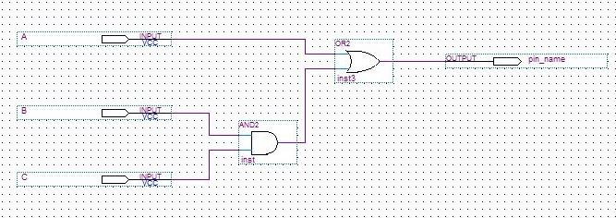

**Figure:** AND-OR logic diagram of the SOP function

**3. Product of Sums:**

CD 00 01 11 10

|  |  |  |  |
| --- | --- | --- | --- |
| 0 | 0 | 0 | 0 |
| 0 | 0 |  |  |
|  |  |  |  |
|  |  |  |  |

AB

00

01

11

10

F(A, B, C, D) = (A+B) (A+C)

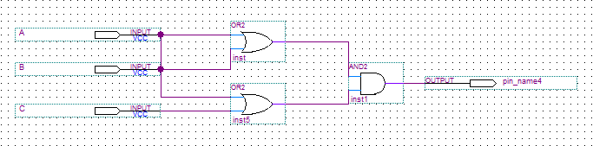

**Figure:** OR-AND logic diagram of the POS function.